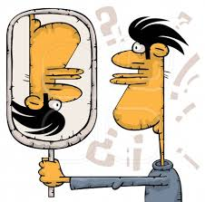

**DOCUMENTO 2**

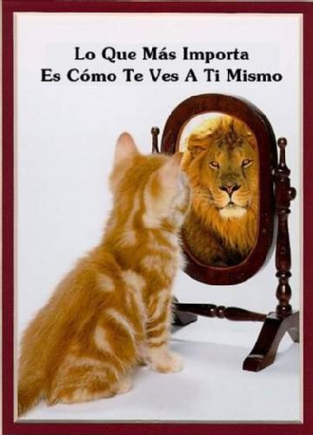

…………………………………………………………………………………………..

…………………………………………………………………………………………..

………………………………………………………………………………………….

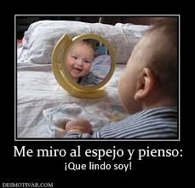

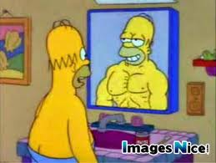

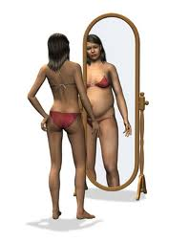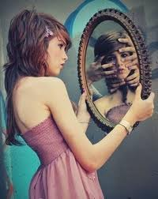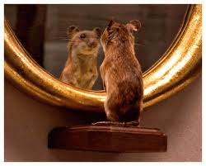

[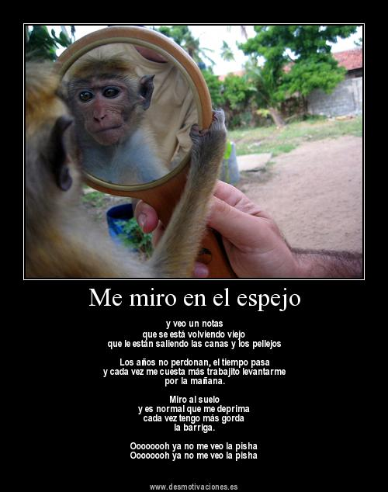](http://www.google.es/url?sa=i&rct=j&q=&esrc=s&frm=1&source=images&cd=&cad=rja&docid=2xOiMrDT1JwcbM&tbnid=j8lfAyHQuq1KtM:&ved=0CAUQjRw&url=http://desmotivaciones.es/4901308/Me-miro-en-el-espejo&ei=j-suUr7tKcau0wX1-YDIDA&bvm=bv.51773540,d.d2k&psig=AFQjCNHbghOKyxMYbpZIghpna1JGBjfOTw&ust=1378893032976401)